PA Amplifier with ECHO/USB/SD & FM & Blue Tooth
FA-120EB/FA-240EB/FA-350EB/FA-500EB
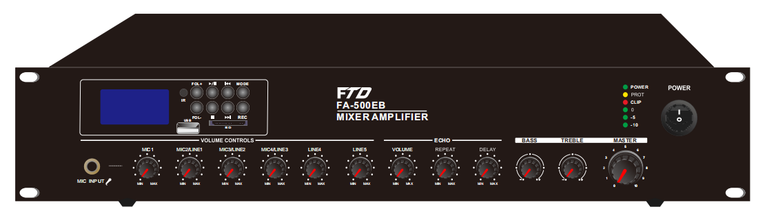

Description:
The Public Address (PA) Mixer Amplifier is suitable for school, super market, bank, hotel BGM and speech use.

It is integrate pre amplifier, Mp3 player and mixer power amplifier into one 19” 2U height unit of tabletop design, which is
economy but of high reliable performance..

The rack size mixer amplifier rated power out at 60W-500w. Its speaker outputs with 100V, 70V and 4‐16ohms for versatile connections.

It integrates three microphone and two line inputs. Mic1 VOX with priority. Microphone1 on front panel by phone jack, microphone2‐3 on rear panel by phone jack, line 1‐2 on rear panel by RCA inputs. Microphone1‐3 & Line1‐2 inputs volume control on front panel with bass and treble tone control.

The amplifier is design with complete protection of overload, short circuit and high temp to avoid any damage.

Features:

- 19” rack mount public address amplifier with Large screen
- PA amplifier with Mp3 player, FM radio & blue tooth and SD card
- Echo with delay time, times and echo volume control
- Rate power output at 120W, 240W, 350W to 500W
- Speaker output of 100V or 70V & 4Ohms-8 Ohms-16 Ohms
- Mp3 player with USB/SD input on front panel, IR remote control for Mp3 player, FM radio and blue tooth
- LED indicators for power, clip, protect and signal
- Mic1 in 6.35 phone jack , MIC2 and MIC3 with phantom power on rear panel. Microphone input or line switchable by DIP switch. Line 3-4 input of RCA input and one RCA line
- EMC input with highest priority
- Volume control for Mic1-3, line1-2, Mp3/FM, bass/treble and master
- With short-circuit, clip, overload and high temp protection
- AC 110 or 220V & 24V DC both operation system
- With 19” rack mount ears

PA Amplifier with ECHO/USB/SD & FM & Blue Tooth
FA-120EB/FA-240EB/FA-350EB/FA-500EB

Rear Panel:
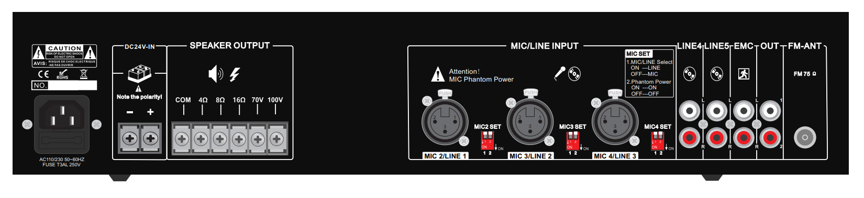

Specification:
Model | FA-120EB | FA-240EB | FA-350EB | FA-500EB
Description | Public Address System 120W Mixer Amplifier
Rated Power Output | 120w | 240w | 350w | 500w
Speaker Output | 70V, 100V and 4-16Ω
Input | Mic1-3: 600 ohms(Ω) 5-8 mV, unbalanced, Line1-2: 10k ohms(Ω) 150-470 mV,  unbalanced
Frequency Response | 60-15KHz
THD | <0.5% at 1kHz, 1/3 rated power
S/N Ratio | Line: 85 dB , MIC: >72 dB
Protection | High temp, short circuit, overload protection
Power Supply | AC230V or DC24V, 50-60Hz
Power Consumption | 150W | 310W | 450W | 650W
Dimension | 484(W)×366(D)×88(H)mm
Packaging: | 484W)×335(D)×88(H)mm
Gross Weight | 6.6kg | 9.6kg | 11.9kg | 13.7kg
Warranty | 3 years

